Logging in to Worker Portal
STEP 1: You can log in to the Worker Portal by clicking the URL below and following the instructions in this document. You will land on the TRG KOG landing page pictured below.
https://kog.chfs.ky.gov/home/

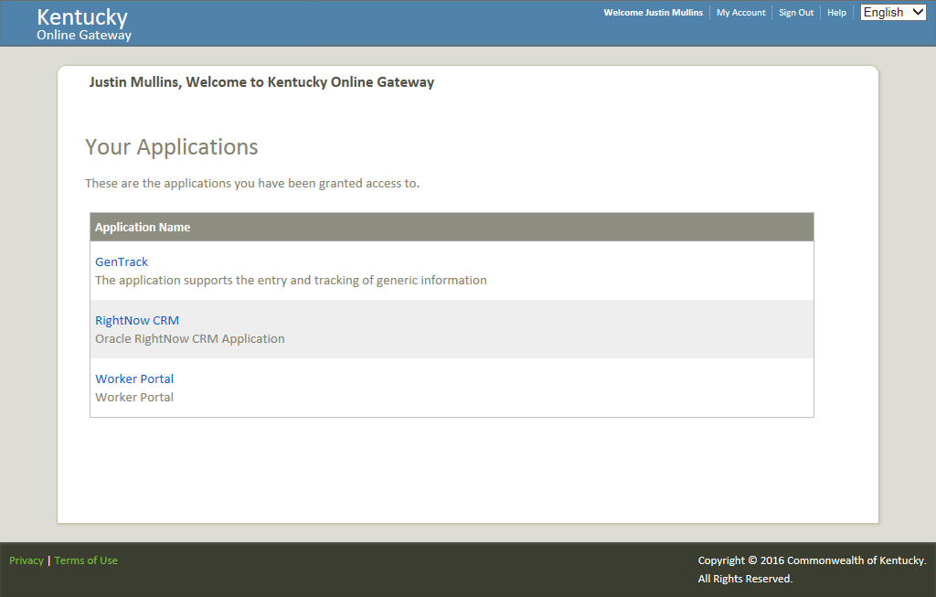
Step 2
Click the Worker Portal hyperlink as indicated in the screen shot.
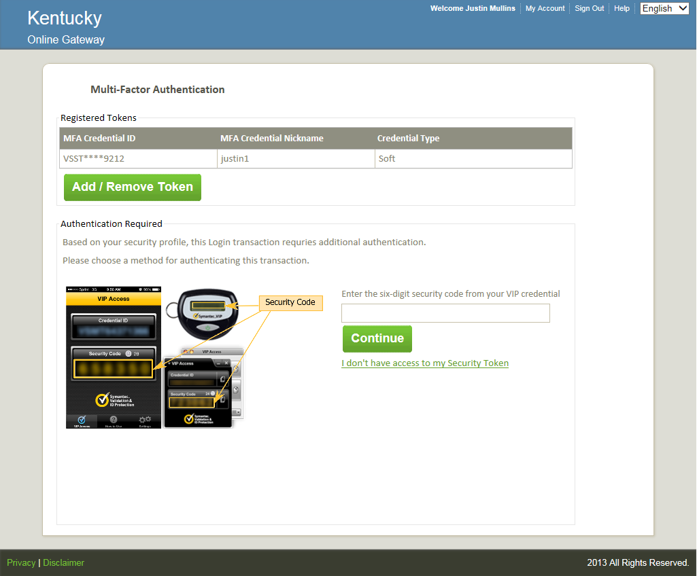
Step 3
Enter you Security Code from your Symantec VIP token and proceed to Step 4
- If you do not have Symantec VIP installed, need to register your Multi-factor ID, or Add or Remove tokens please see the instructions beginning on page 3 before proceeding to Step 4.
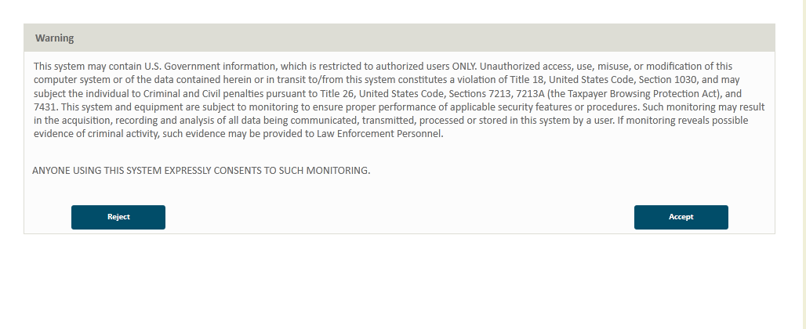
Step 4
Click the Accept button
Step 4:
Click the Accept button

VIP Access – Installation and Maintenance

Step 1: Multi-Factor Access (MFA) for Login - Symantec VIP Access Installation
The following steps are for multi-factor authentication (MFA) through soft token.
- Download Symantec VIP Access Desktop Software. The software is available for mobile as well as desktop. Please download the required type. https://idprotect.vip.symantec.com/mainmenu.v
- Install the Symantec VIP Access Desktop Software
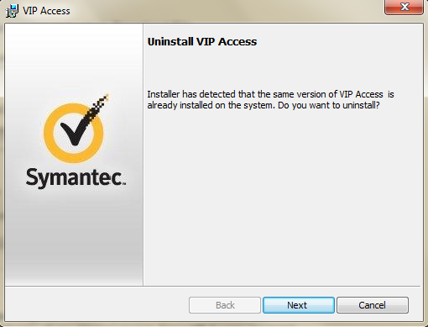

- Select the Desktop option.
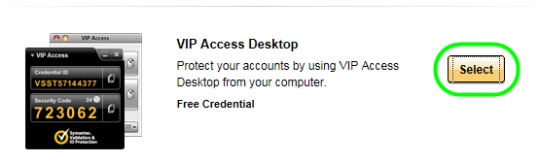

- 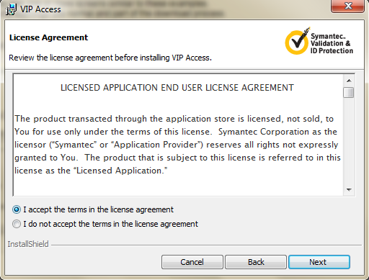

- 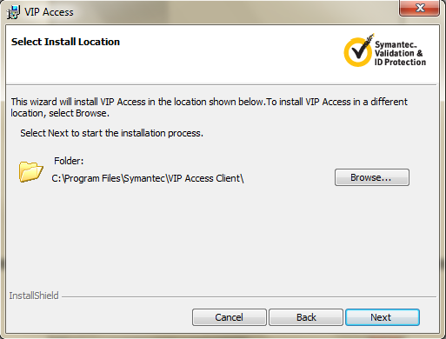

- 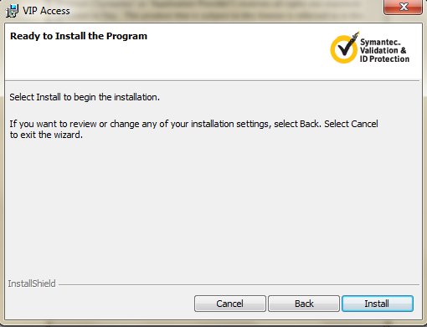

- 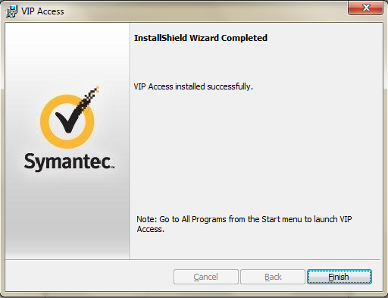

- Run VIP Access from Windows Start Menu
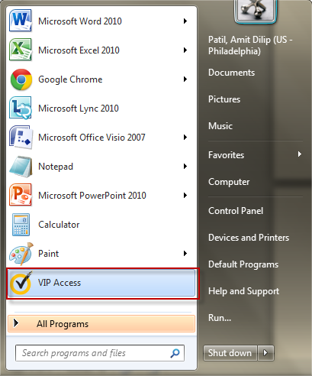
- Verify VIP Access window will appear on desktop.
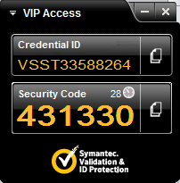

1.2 Registering your Multi-Factor Access (MFA) ID
- After you have logged in with a User Account based on previous sections, register your Credential ID. The following step will be performed during initial login. After the Credential ID was been provided for the first time, subsequent logins will only require the Security Code.

- 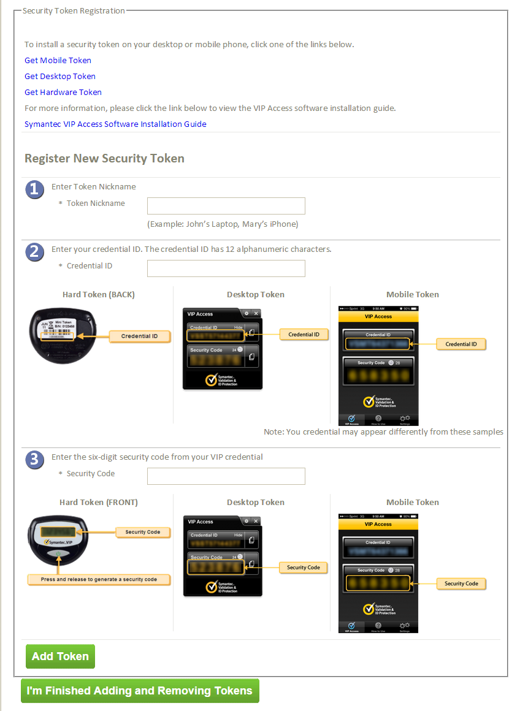

- After the Credential ID has been registered, if there are 3 Tokens/MFA Credential ID registered, you will see the message of “You have reached the maximum allowed limit Tokens. To add more, please remove one of them.” No such message will display if there are 2 or less Tokens registered.
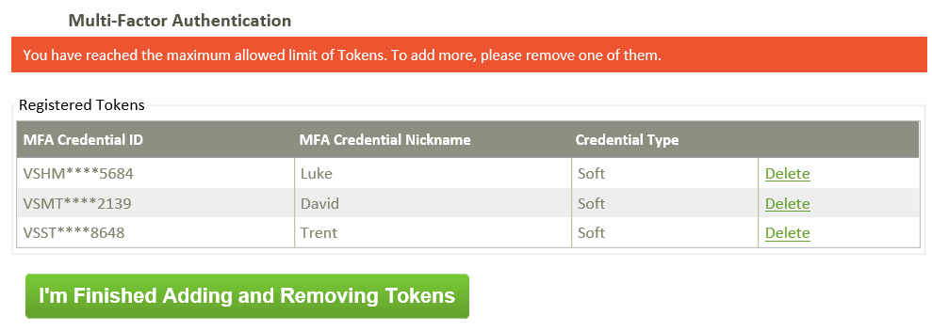

- Perform MFA. Run VIP Access from Windows Start Menu

- VIP Access window will appear on desktop.

- Enter the VIP Security code, and Click Continue button.
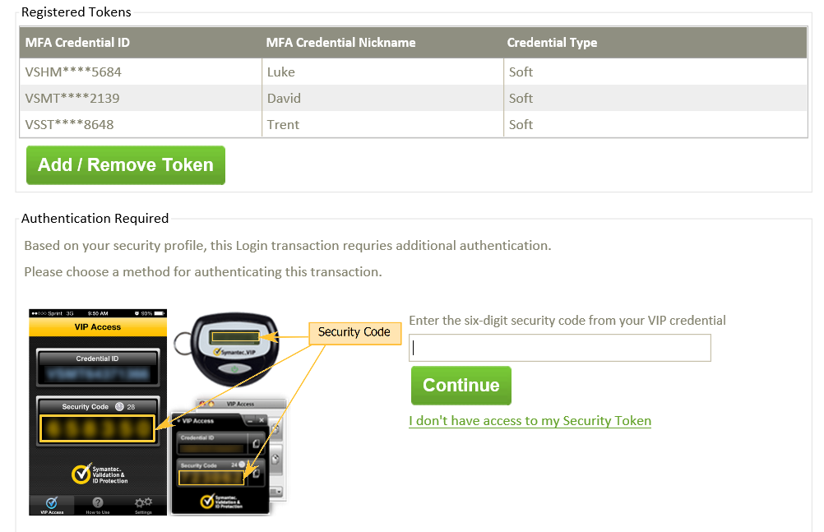
1.3 Add/remove Existing Multi-Factor Access (MFA) ID
- If there is at least one Token registered on the account which you do NOT have access to, you may need to use ““I don’t have access to my Security Token,” to add/remove MFA IDs. Click on “I don’t have my token,” then Request Temporary Security Code.

